A PROJECT REPORT ON

Personal portfolio Website

A Report Submitted to

IIDT - Blackbuck Engineers Pvt. Ltd

Submitted By:

Aashish Kumar sah

22781A05J2

## Acknowledgement

We extend our sincere gratitude to everyone who supported the completion of this project. Special thanks to SVCET for their insightful guidance and encouragement throughout the development process. We also appreciate the collaborative efforts of myself and my team members, whose contributions were invaluable. Our appreciation goes to IIDT - Blackbuck Engineers Pvt. Ltd for providing the resources and support needed. Finally, we thank our families and friends for their unwavering encouragement.

## Abstract

This project involves the development of a personal portfolio website designed to showcase individual skills, projects, and contact information. The website features a responsive navigation menu, a typing effect for displaying skills, and scroll animations for a dynamic user experience. The project leverages modern web technologies such as HTML, CSS, and JavaScript, including libraries like Typed.js and Scroll Reveal. The primary goal is to create an engaging and visually appealing portfolio that enhances personal branding.

## Introduction

In today’s digital age, a personal portfolio website is a crucial tool for professionals to showcase their work and skills. This project addresses the need for a well-designed, responsive portfolio site. The website includes various features such as a dynamic navigation menu, animations, and interactive elements to provide a compelling user experience. The project aims to demonstrate proficiency in frontend development and create a platform for personal branding.

## Advantages

1. **Responsive Design**: The website adapts to different screen sizes, ensuring a seamless experience on both desktop and mobile devices.
2. **Interactive Features**: Includes dynamic elements like a typing effect and scroll animations to engage users.
3. **User-Friendly Navigation**: The navigation menu is easy to use and closes automatically when a menu item is clicked, enhancing usability.

## Disadvantages

1. **Performance Overhead**: Advanced animations and effects may impact performance on lower-end devices.
2. **Browser Compatibility**: Some CSS and JavaScript features may not work consistently across all browsers.
3. **Maintenance**: Regular updates may be required to keep the website functioning optimally with new web technologies.

## Software and Hardware Requirements

### Software Requirements

* **Operating System**: Windows 10, macOS Big Sur, or any modern OS.
* **Web Browser**: Google Chrome, Mozilla Firefox, or any modern browser.
* **Development Tools**: Visual Studio Code or any code editor, Git for version control.
* **Libraries/Frameworks**: Typed.js for typing effects, ScrollReveal for animations.

### Hardware Requirements

* **Processor**: Intel i5 or equivalent.
* **RAM**: 8 GB or more.
* **Storage**: 256 GB SSD or more.
* **Network**: Stable internet connection for development and testing.

## Motivation

The motivation behind this project is to create a visually appealing and functional personal portfolio website that effectively showcases skills and projects. With increasing competition in the job market, having a standout portfolio is essential for making a strong impression. This project aims to provide a comprehensive platform that highlights individual achievements and capabilities.

## Literature Review

The literature review includes relevant studies and resources on web development and design principles:

1. **"Responsive Web Design"** by Ethan Marcotte - Discusses the principles of responsive design and its importance for modern websites.
2. **"JavaScript and JQuery: Interactive Front-End Web Development"** by Jon Duckett - Covers JavaScript and JQuery techniques for creating interactive web elements.
3. **"CSS Secrets: Better Solutions to Everyday Web Design Problems"** by Lea Verou - Provides insights into advanced CSS techniques for enhancing website design.

These sources offer foundational knowledge and best practices for implementing the features in this project.

## Existing System

Existing portfolio websites often include:

1. **Simple Static Pages**: Basic HTML and CSS-based portfolios with minimal interactivity.
2. **Template-Based Portfolios**: Pre-designed templates that users can customize, offering limited flexibility.
3. **Dynamic Portfolios with CMS**: Portfolios integrated with Content Management Systems (CMS) like WordPress, providing easy content updates but often lacking in design uniqueness.

Despite their advantages, these systems may not always offer the level of customization or interactivity desired.

## Proposed System

The proposed system addresses the limitations of existing portfolio websites by incorporating:

1. **Responsive Navigation Menu**: Ensures usability across devices with a responsive design.
2. **Typing Effect**: Adds a dynamic element to showcase skills in a visually engaging manner.
3. **Scroll Reveal Animations**: Enhances user experience by animating content as it comes into view.

These features aim to create a more engaging and personalized portfolio experience.

## Keywords and Definitions

* **Responsive Design**: Design approach that ensures a website functions well on various devices and screen sizes.
* **Typing Effect**: An animation that simulates text being typed out on screen.
* **Scroll Reveal**: A JavaScript library for animating elements as they scroll into view.

## Implementation

The implementation of the project involves:

1. **Frontend Development**: Building the user interface using HTML, CSS, and JavaScript.
2. **Feature Integration**: Adding interactive elements such as the typing effect and scroll animations.
3. **Testing and Optimization**: Ensuring the website performs well across different devices and browsers.

## Challenges Faced

1. **Performance Issues**: Animations and effects may impact performance on older devices. Solution: Optimized animations and implemented fallback options.
2. **Cross-Browser Compatibility**: Ensuring consistent behavior across different browsers. Solution: Used polyfills and tested on multiple browsers.
3. **Responsive Design**: Achieving a seamless experience on various screen sizes. Solution: Implemented media queries and flexible layouts.

## System Testing

### Unit Testing

Unit tests were conducted for individual components to ensure they function correctly:

1. **Navigation Menu**: Tested responsiveness and functionality.
2. **Typing Effect**: Verified proper execution and timing.

### Integration Testing

Integration tests focused on interactions between components:

1. **Menu and Content**: Ensured the menu links correctly navigate to different sections.
2. **Animations and User Interaction**: Verified that animations trigger appropriately on user actions.

### Performance Testing

Performance tests evaluated the website’s performance under different conditions:

1. **Load Time**: Measured time to load the website on various devices.
2. **Responsiveness**: Tested the website’s responsiveness under different network speeds.

### Acceptance Testing

Acceptance testing ensured the website met user requirements:

1. **Functionality**: Verified that all features work as expected.
2. **Usability**: Assessed user experience and ease of navigation.

## Test Results

* **Unit Test Results**: All individual components performed as expected with minor issues addressed.
* **Integration Test Results**: Smooth interaction between components with all integrations functioning correctly.
* **Performance Test Results**: The website performed well under normal conditions, with optimizations in place for performance issues.
* **Acceptance Test Results**: User feedback was positive, with all requirements met.

**Coding:**

**Index.html**

<!DOCTYPE html>

<html lang="en">

    <head>

        <meta charset="UTF-8">

        <meta name="viewport" content="width=device-width, initial-scale=1.0">

        <title>Portfolio | Aashish </title>

        <!-- UNICONS -->

        <link rel="stylesheet"

            href="https://unicons.iconscout.com/release/v4.0.8/css/line.css">

        <!-- LINK CSS -->

        <link rel="stylesheet" href="assets/css/style.css">

    </head>

    <body>

        <div class="containeer">

            <!-- HEADER -->

            <nav id="header">

                <div class="nav-logo">

                    <p class="nav-name">Aashish</p>

                    <span>.</span>

                </div>

                <div class="nav-menu" id="myNavMenu">

                    <ul class="nav-menu-list">

                        <li class="nav-list">

                            <a href="#home"

                                class="nav-link active-link">Home</a>

                            <div class="circle"></div>

                        </li>

                        <li class="nav-list">

                            <a href="#about" class="nav-link">About</a>

                            <div class="circle"></div>

                        </li>

                        <li class="nav-list">

                            <a href="#projects" class="nav-link">Projects</a>

                            <div class="circle"></div>

                        </li>

                        <li class="nav-list">

                            <a href="#contact" class="nav-link">Contact</a>

                            <div class="circle"></div>

                        </li>

                    </ul>

                </div>

                <div class="nav-button">

                    <button class="btn">Download CV <i

                            class="uil uil-file-alt"></i></button>

                </div>

                <div class="nav-bar">

                    <i class="uil uil-bars" onclick="myMenuFunction()"></i>

                </div>

            </nav>

            <!-- MAIN -->

            <main class="wrapper">

                <!-- HOME BOX -->

                <section class="featured-box" id="home">

                    <div class="featured-text">

                        <div class="featured-text-card">

                            <span>Aashish sah</span>

                        </div>

                        <div class="featured-name">

                            <p>I'm <span class="typedText"></span></p>

                        </div>

                        <div class="featured-text-info">

                            <p>Well Experienced Developer, Full stack

                                Experience, DataBase (SQLite, MongoDB)</p>

                        </div>

                        <div class="featured-btn">

                           <a href="#contact"><button class="btn blue-btn">Let's Connect</button></a>

                            <button class="btn">Download CV <i

                                    class="uil uil-file-alt"></i></button>

                        </div>

                        <div class="social-icons">

                            <div class="icon">

                                <a

                                    href="https://www.instagram.com/_aashish_sah?igsh=czV1eXE2NHNqNXN1">

                                    <i class="uil uil-instagram"></i></a></div>

                            <div class="icon"> <a

                                    href="https://www.linkedin.com/in/aashish-sah-a6549b287?utm_source=share&utm_campaign=share_via&utm_content=profile&utm_medium=android_app"><i

                                        class="uil uil-linkedin-alt"></i></a></div>

                            <div class="icon"> <a

                                    href="https://x.com/Aashish29372044?t=Ettz38lbDCgEOMu_ckQeXg&s=09"><i

                                        class="uil uil-twitter-alt"></i></a></div>

                            <div class="icon"> <a

                                    href="https://github.com/Aas-hish"><i

                                        class="uil uil-github-alt"></i></a>

                            </div>

                        </div>

                    </div>

                    <div class="featured-image">

                        <div class="image">

                            <img src="assets/images/Aashish.JPG" alt="avatar">

                        </div>

                    </div>

                    <div class="scroll-down-btn">

                        <a href="#about" class="scroll-btn">

                            <i class="uil uil-mouse-alt"></i>

                            <p>Scroll Down</p>

                        </a>

                    </div>

                </section>

                <!-- ABOUT BOX -->

                <section class="section" id="about">

                    <div class="top-header">

                        <h1>About Me</h1>

                    </div>

                    <div class="row">

                        <div class="col">

                            <div class="about-info">

                                <h3>My Introduction</h3>

                                <p>I am well experienced in HTML, CSS and

                                    javascript, and other cutting edges

                                    frameworks and libraries. I have also

                                    experience in DataBase and Backend Lorem

                                    ipsum dolor sit amet consectetur adipisicing

                                    elit. Dicta a cum esse. Lorem ipsum dolor

                                    sit, amet consectetur adipisicing elit.

                                    Beatae ullam mollitia placeat nemo dicta

                                    tempora ex! Tempore, ipsa! Quisquam, id?

                                </p>

                                <div class="about-btn">

                                    <button class="btn">Download CV <i

                                            class="uil uil-import"></i></button>

                                </div>

                            </div>

                        </div>

                        <div class="col">

                            <div class="skill-header">

                                <div class="skill-box">

                                    <h3>Frontend</h3>

                                </div>

                                <div class="skill-list">

                                    <span>HTML</span>

                                    <span>CSS</span>

                                    <span>Bootstrap</span>

                                    <span>JavaScript</span>

                                    <span>Tailwind CSS</span>

                                    <span>React</span>

                                </div>

                            </div>

                            <div class="skill-header">

                                <div class="skill-box">

                                    <h3>Backend</h3>

                                </div>

                                <div class="skill-list">

                                    <span>PHP</span>

                                    <span>Java</span>

                                    <span>C++</span>

                                    <span>Python</span>

                                </div>

                            </div>

                            <div class="skill-header">

                                <div class="skill-box">

                                    <h3>DataBase</h3>

                                </div>

                                <div class="skill-list">

                                    <span>MySQL</span>

                                    <span>MongoDB</span>

                                </div>

                            </div>

                        </div>

                    </div>

                </section>

                <!-- PROJECT BOX -->

                <section class="section" id="projects">

                    <div class="top-header">

                        <h1>Projects</h1>

                    </div>

                    <div class="project-container">

                        <div class="project-box">

                            <i class="uil uil-briefcase-alt"></i>

                            <h3>Completed</h3>

                            <label>15+ finished Projects</label>

                            <button  class="view-more">View More</button>

                        </div>

                        <div class="project-box">

                            <i class="uil uil-notebooks"></i>

                            <h3>Certificates</h3>

                            <label>10+ Certificates</label>

                            <button id="view-more-btn" class="view-more">View More</button>

                        </div>

                        <div class="project-box">

                            <i class="uil uil-award"></i>

                            <h3>Experience</h3>

                            <label>Learning / Beginner</label>

                            <button  class="view-more">View More</button>

                        </div>

                    </div>

                </section>

                <!-- CONTACT BOX -->

                <section class="section" id="contact">

                    <div class="top-header">

                        <h1>Get in touch</h1>

                        <span>Do you have project in your mind, contact

                            me</span>

                    </div>

                    <div class="row">

                        <div class="col">

                            <div class="contact-info">

                                <h2>Find Me <i

                                        class="uil uil-corner-right-down"></i></h2>

                                <p><i class="uil uil-envelope"></i> Email:

                                    rebelraaz2@gmail.com</p>

                                <p><i class="uil uil-phone"></i> Tel: +91

                                    6305245701</p>

                            </div>

                        </div>

                        <div class="col">

                            <div class="form-control">

                                <div class="form-inputs">

                                    <input type="text" class="input-field"

                                        placeholder="Name">

                                    <input type="text" class="input-field"

                                        placeholder="Email">

                                </div>

                                <div class="text-area">

                                    <textarea placeholder="Message"></textarea>

                                </div>

                                <div class="form-button">

                                    <button class="btn">Send Message <i

                                            class="uil uil-message"></i></button>

                                </div>

                            </div>

                        </div>

                    </div>

                </section>

            </main>

            <!-- FOOTER -->

            <footer class="footer">

                <div class="top-footer">

                    <p>Aashish Sah .</p>

                </div>

                <div class="middle-footer">

                    <ul class="footer-menu">

                        <li class="footer-menu-list">

                            <a href="#home">Home</a>

                        </li>

                        <li class="footer-menu-list">

                            <a href="#about">About</a>

                        </li>

                        <li class="footer-menu-list">

                            <a href="#projects">Projects</a>

                        </li>

                        <li class="footer-menu-list">

                            <a href="#contact">Contact</a>

                        </li>

                    </ul>

                </div>

                <div class="footer-social-icons">

                    <div class="icon">

                        <a

                            href="https://www.instagram.com/_aashish_sah?igsh=czV1eXE2NHNqNXN1">

                            <i class="uil uil-instagram"></i></a></div>

                    <div class="icon"> <a

                            href="https://www.linkedin.com/in/aashish-sah-a6549b287?utm_source=share&utm_campaign=share_via&utm_content=profile&utm_medium=android_app"><i

                                class="uil uil-linkedin-alt"></i></a></div>

                    <div class="icon"> <a

                            href="https://x.com/Aashish29372044?t=Ettz38lbDCgEOMu_ckQeXg&s=09"><i

                                class="uil uil-twitter-alt"></i></a></div>

                    <div class="icon"> <a href="https://github.com/Aas-hish"><i

                                class="uil uil-github-alt"></i></a> </div>

                </div>

                <div class="bottom-footer">

                    <p>Copyright &copy; <a href="#home"

                            style="text-decoration: none;">Aashish Sah</a> - All

                        rights reserved</p>

                </div>

            </footer>

            <!-- Pop Up screen -->

             <div class="pop-up-screen">

                <div class="screen">

                    <div class="close">+</div>

                    <h2>Certificates</h2>

        <ul class="certificate-list">

            <li><img src="certificate1.jpg" alt="Certificate 1" class="certificate-image" data-url="certificate1.jpg"></li>

            <li><img src="certificate2.jpg" alt="Certificate 2" class="certificate-image" data-url="certificate2.jpg"></li>

            <li><img src="certificate3.jpg" alt="Certificate 3" class="certificate-image" data-url="certificate3.jpg"></li>

            <li><img src="certificate4.jpg" alt="Certificate 4" class="certificate-image" data-url="certificate4.jpg"></li>

            <li><img src="certificate5.jpg" alt="Certificate 5" class="certificate-image" data-url="certificate5.jpg"></li>

            <li><img src="certificate6.jpg" alt="Certificate 6" class="certificate-image" data-url="certificate6.jpg"></li>

            <li><img src="certificate7.jpg" alt="Certificate 7" class="certificate-image" data-url="certificate7.jpg"></li>

            <li><img src="certificate8.jpg" alt="Certificate 8" class="certificate-image" data-url="certificate8.jpg"></li>

            <li><img src="certificate9.jpg" alt="Certificate 9" class="certificate-image" data-url="certificate9.jpg"></li>

            <li><img src="certificate10.jpg" alt="Certificate 10" class="certificate-image" data-url="certificate10.jpg"></li>

        </ul>

                </div>

             </div>

        </div>

        <!-- Typed js link -->

        <script

            src="https://unpkg.com/typed.js@2.1.0/dist/typed.umd.js"></script>

        <!-- JS scroll link -->

        <script src="https://unpkg.com/scrollreveal"></script>

        <!-- Main JS link -->

        <script src="assets/js/main.js"></script>

    </body>

</html>

Style.css

/* link font */

@import url('https://fonts.googleapis.com/css2?family=Poppins&display=swap');

/* Variables */

:root {

    --body-color: rgb(250, 250, 250);

    --color-white: rgb(255, 255, 255);

    --text-second-color: rgb(68, 68, 68);

    --text-third-color: rgb(30, 159, 171);

    --first-color: rgb(110, 87, 224);

    --first-color-hover: rgb(40, 91, 212);

    --second-color: rgb(0, 201, 255);

    --third-color: rgb(192, 166, 49);

    --first-shadow-color: rgba(0, 0, 0, 0.1);

}

/* Base */

* {

    padding: 0;

    margin: 0;

    box-sizing: border-box;

    font-family: 'Poppins', sans-serif;

    user-select: none;

}

/* SMOOTH SCROLL */

html {

    scroll-behavior: smooth;

}

/* CHANGE THE SCROLL BAR DESIGN */

::-webkit-scrollbar {

    width: 10px;

    border-radius: 25px;

}

::-webkit-scrollbar-track {

    background: #f1f1f1;

}

::-webkit-scrollbar-thumb {

    background: #ccc;

    border-radius: 30px;

}

::-webkit-scrollbar-thumb:hover {

    background: #bbb;

}

/* GLOBAL BUTTON DESIGN */

.btn {

    font-weight: 400;

    padding: 12px 20px;

    background: #efefef;

    border-radius: 10px;

    border: none;

    cursor: pointer;

    transition: .4s;

}

.btn>i {

    margin-left: 10px;

}

.btn:hover {

    background: var(--second-color);

    color: var(--color-white);

}

/* GLOBAL ICON DESIGN */

i {

    font-size: 16px;

}

/* BASE */

body {

    background: var(--body-color);

}

.containeer {

    width: 100%;

    position: relative;

}

/* ---- Nav BAR---- */

nav {

    position: fixed;

    display: flex;

    justify-content: space-between;

    width: 100%;

    height: 90px;

    line-height: 90px;

    padding-inline: 9vw;

    background: var(--body-color);

    transition: .3s;

    z-index: 100;

}

.nav-logo {

    position: relative;

}

.nav-name {

    font-size: 30px;

    font-weight: 600;

    color: var(--text-third-color);

}

.nav-logo span {

    position: absolute;

    top: -15px;

    right: -20px;

    font-size: 5em;

    color: var(--text-second-color);

}

.nav-menu,

.nav-menu-list {

    display: flex;

}

.nav-menu .nav-list {

    list-style: none;

    position: relative;

}

.nav-link {

    text-decoration: none;

    color: var(--text-second-color);

    font-weight: 500;

    padding-inline: 15px;

    margin-inline: 20px;

}

.nav-bar {

    display: none;

}

.nav-bar i {

    font-size: 28px;

    cursor: pointer;

}

.active-link {

    position: relative;

    color: var(--first-color);

    transition: .3;

}

.active-link::after {

    content: "";

    position: absolute;

    left: 50%;

    bottom: -15px;

    width: 5px;

    height: 5px;

    background: var(--first-color);

    border-radius: 50%;

}

/* ---WRAPPER DESIGN--- */

.wrapper {

    padding-inline: 10vw;

}

/* Featured Box */

.featured-box {

    position: relative;

    display: flex;

    height: 100vh;

    min-height: 700px;

}

/* Featured text  */

.featured-text {

    position: relative;

    display: flex;

    min-height: 80vh;

    flex-direction: column;

    justify-content: center;

    align-content: center;

    width: 50%;

    padding-left: 20px;

}

/* featured-text-card */

.featured-text-card span {

    background: var(--third-color);

    color: var(--color-white);

    border-radius: 5px;

    font-size: 12px;

    padding: 3px 8px;

}

/* featured-name */

.featured-name {

    font-size: 50px;

    font-weight: 600;

    color: var(--text-second-color);

    margin-block: 20px;

}

.typedText {

    text-transform: capitalize;

    color: var(--text-third-color);

}

/* featured-text-info */

.featured-text-info {

    font-size: 16px;

    color: var(--text-second-color);

    margin-bottom: 30px;

}

/* featured-btn */

.featured-btn {

    display: flex;

    gap: 30px;

}

.blue-btn {

    background: var(--third-color);

    color: var(--color-white);

}

.blue-btn:hover {

    background: #efefef;

    color: black;

}

/* social-icons */

.social-icons {

    display: flex;

    margin-top: 4em;

    gap: 30px;

}

.icon {

    display: flex;

    justify-content: center;

    align-items: center;

    height: 40px;

    width: 40px;

    border-radius: 50%;

    box-shadow: 0px 2px 5px 0px rgba(0, 0, 0, 0.6);

    cursor: pointer;

}

.icon:hover {

    color: var(--first-color-hover);

}

/* featured-image */

.featured-image {

    display: flex;

    justify-content: right;

    align-content: center;

    min-height: 80vh;

    width: 50%;

}

.image {

    margin: auto 0;

    width: 380px;

    height: 380px;

    border-radius: 55% 45% 55% 45%;

    box-shadow: 0 0 15px var(--text-third-color);

    overflow: hidden;

    animation: imgFloat 7s ease-in-out infinite;

}

.image img {

    width: 380px;

    height: 380px;

    object-fit: cover;

}

@keyframes imgFloat {

    50% {

        transform: translateY(10px);

        border-radius: 45% 55% 45% 55%;

    }

}

.scroll-btn {

    position: absolute;

    bottom: 0;

    left: 50%;

    transform: translateX(-50%);

    display: flex;

    box-shadow: 0 2px 5px 0 rgba(0, 0, 0, 0.25);

    justify-content: center;

    align-items: center;

    width: 150px;

    height: 50px;

    gap: 5px;

    text-decoration: none;

    color: var(--text-second-color);

    background: var(--color-white);

    border-radius: 30px;

}

.scroll-btn i {

    font-size: 20px;

}

/* ABOUT BOX */

.section {

    padding-block: 5em;

}

.row {

    display: flex;

    justify-content: space-between;

    width: 100%;

    gap: 50px;

}

.col {

    display: flex;

    width: 50%;

    margin-top: 30px;

}

/* REUSABLE CSS */

.top-header {

    text-align: center;

    justify-content: center;

}

.top-header h1 {

    font-weight: 600;

    color: var(--text-second-color);

    margin-bottom: 20px;

}

.top-header span {

    color: #999;

}

h3 {

    font-size: 20px;

    font-weight: 600;

    color: var(--text-second-color);

    margin-bottom: 15px;

}

.about-info {

    position: relative;

    display: flex;

    align-items: center;

    flex-direction: column;

    width: 100%;

    padding-block: 30px 70px;

    padding-inline: 20px;

    background: var(--color-white);

    box-shadow: 1px 8px 10px 2px var(--first-shadow-color);

    border-radius: 20px;

}

.about-info p {

    font-size: 16px;

    text-align: center;

    color: #777;

}

.about-btn button {

    position: absolute;

    right: 20px;

    bottom: 20px;

    background: var(--first-color);

    color: var(--color-white);

    border-radius: 30px;

}

.about-btn button:hover {

    background: var(--first-color-hover);

}

/* ABOUT / SKILL BOX */

.skill-box {

    margin: 10px;

}

.skill-header {

    margin-bottom: 30px;

}

.skill-list {

    display: flex;

    flex-wrap: wrap;

    gap: 5px;

}

.skill-list span {

    font-size: 14px;

    background: var(--first-color);

    color: var(--color-white);

    padding: 2px 10px;

    border-radius: 5px;

}

/* PROJECT BOX */

.project-container {

    display: flex;

    width: 100%;

    justify-content: space-between;

    gap: 20px;

    flex-wrap: wrap;

}

.project-box {

    position: relative;

    display: flex;

    justify-content: center;

    align-items: center;

    flex-direction: column;

    width: 30%;

    height: 250px;

    background: var(--color-white);

    border-radius: 20px;

    box-shadow: 1px 8px 10px 2px var(--first-shadow-color);

    overflow: hidden;

}

.project-box>i {

    font-size: 50px;

    color: #00B5E7;

    margin-bottom: 25px;

}

.project-box label {

    font-size: 15px;

    color: #777;

}

.project-box::after,

.contact-info::after {

    content: "";

    position: absolute;

    background: var(--second-color);

    bottom: -100%;

    width: 100%;

    height: 100%;

    transition: .4s;

    z-index: 1;

}

.project-box:hover::after,

.contact-info:hover::after {

    bottom: 0;

}

.project-box:hover i,

.project-box:hover h3 {

    color: var(--color-white);

    z-index: 2;

}

.project-box .view-more {

    position: absolute;

    bottom: 20px;

    padding: 10px 20px;

    background-color: var(--color-white);

    color: var(--second-color);

    border: none;

    border-radius: 15px;

    cursor: pointer;

    opacity: 0;

    transition: opacity 0.4s;

    z-index: 2;

}

.project-box:hover .view-more {

    opacity: 1;

}

/* POP UP SCREEN */

.pop-up-screen {

    height: 100%;

    width: 100%;

    background: rgba(0, 0, 0, 0.7);

    position: fixed;

    top: 0;

    display: flex;

    justify-content: center;

    align-items: center;

    display: none;

}

.screen {

    width: 700px;

    max-height: 70vh;

    background-color: var(--body-color);

    border-radius: 10px;

    position: relative;

    overflow-y: auto;

}

.close {

    position: absolute;

    right: 25px;

    font-size: 42px;

    cursor: pointer;

    rotate: -45deg;

    color: var(--text-second-color);

}

.certificate-list {

    list-style: none;

    padding: 0;

    margin-top: 20px;

}

.certificate-list li {

    margin: 10px 0;

    padding: 10px;

    background-color: var(--color-white);

    border-radius: 5px;

    box-shadow: 1px 1px 5px rgba(0, 0, 0, 0.1);

}

/* CONTACT BOX */

.contact-info {

    position: relative;

    display: flex;

    flex-direction: column;

    justify-content: center;

    align-items: center;

    padding: 20px 30px;

    width: 100%;

    height: 315px;

    background: var(--second-color);

    border-radius: 10px;

    box-shadow: 1px 8px 10px 2px var(--first-shadow-color);

    overflow: hidden;

}

.contact-info>h2 {

    color: var(--color-white);

    margin-bottom: 20px;

}

.contact-info>p {

    color: var(--color-white);

    display: flex;

    align-items: center;

    gap: 10px;

    margin-block: 5px;

}

.contact-info p>i {

    font-size: 18px;

}

.contact-info::after {

background: var(--color-white);

}

.contact-info:hover.contact-info h2,

.contact-info:hover.contact-info p,

.contact-info:hover.contact-info i {

    color: #777;

    z-index: 2;

}

.form-control {

    display: flex;

    flex-direction: column;

    gap: 10px;

    width: 100%;

}

.form-inputs {

    display: flex;

    gap: 10px;

    width: 100%;

}

.input-field {

    width: 50%;

    height: 55px;

    background: transparent;

    border: 2px solid #AAA;

    padding-inline: 20px;

    border-radius: 10px;

    outline: none;

}

textarea {

    width: 100%;

    height: 200px;

    background: transparent;

    padding: 15px 20px;

    border: 2px solid #AAA;

    outline: none;

    border-radius: 10px;

    resize: none;

}

.form-button>.btn {

    display: flex;

    align-items: center;

    justify-content: center;

    background: var(--second-color);

    color: var(--color-white);

}

.form-button>.btn:hover {

    background: #00b5e7;

}

.form-button i:hover {

    font-size: 16px;

    rotate: -45deg;

}

/* FOOTER BOX */

.footer {

    display: flex;

    justify-content: center;

    align-items: center;

    flex-direction: column;

    row-gap: 30px;

    background: #f8f8f8;

    padding-block: 40px 60px;

}

.top-footer p {

    font-size: 25px;

    font-weight: 600;

}

.middle-footer .footer-menu {

    display: flex;

}

.footer-menu-list {

    list-style: none;

}

.footer-menu-list a {

    text-decoration: none;

    color: var(--text-second-color);

    font-weight: 500;

    margin-inline: 20px;

}

.footer-menu-list a:hover {

    color: var(--first-color);

}

.footer-social-icons {

    display: flex;

    gap: 30px;

}

.bottom-footer {

    font-size: 18px;

    font-weight: 500;

}

/* --- MEDIA QUERY === 900PX /RESPONSIVE ----- */

@media only screen and (max-width:1024px) {

    .featured-text {

        padding: 0;

    }

    .image,

    .image img {

        width: 320px;

        height: 320px;

    }

}

/* --- MEDIA QUERY === 900PX /RESPONSIVE ----- */

@media only screen and (max-width: 900px) {

    .nav-button {

        display: none;

    }

    .nav-menu.responsive {

        left: 0;

    }

    .nav-menu {

        position: fixed;

        top: 80px;

        left: -100%;

        flex-direction: column;

        justify-content: center;

        align-items: center;

        background: rgba(183, 183, 183, 0.7);

        backdrop-filter: blur(20px);

        width: 100%;

        border-radius: 50px;

        min-height: 450px;

        height: 90vh;

        transition: .3s;

    }

    .nav-menu-list {

        flex-direction: column;

    }

    .nav-link {

        color: var(--color-white);

        font-weight: 500;

    }

    .nav-bar {

        display: flex;

        align-items: center;

        justify-content: center;

    }

    .featured-box {

        flex-direction: column;

        justify-content: center;

        height: 100vh;

    }

    .featured-text {

        width: 100%;

        justify-content: center;

        align-content: start;

        min-height: 60vh;

        order: 2;

    }

    .featured-image {

        margin-top: 65px;

        order: 1;

        min-height: 150px;

        justify-content: center;

        width: 100%;

    }

    .social-icons {

        margin-top: 2em;

    }

    .image,

    .image img {

        width: 200px;

        height: 200px;

    }

    .row {

        display: flex;

        flex-direction: column;

        justify-content: center;

        gap: 50px;

    }

    .col {

        display: flex;

        justify-content: center;

        width: 100%;

    }

    .about-info,

    .contact-info {

        width: 100%;

    }

    .project-container {

        justify-content: center;

    }

    .project-box {

        width: 80%;

    }

}

/* --- MEDIA QUERY === 540PX /RESPONSIVE ----- */

@media only screen and (max-width:540px) {

    .featured-name {

        font-size: 40px;

    }

    .project-box {

        width: 100%;

    }

    .form-inputs {

        flex-direction: column;

    }

    .input-field {

        width: 100%;

    }

}

Main.js

//   NAV BAR FUNCTION

function myMenuFunction(){

    var menuBtn = document.getElementById("myNavMenu");

    if(menuBtn.className === "nav-menu"){

        menuBtn.className += " responsive";

    }

    else{

        menuBtn.className = "nav-menu";

    }

}

function closeNav() {

    var menuBtn = document.getElementById("myNavMenu");

    menuBtn.className = "nav-menu";

}

// Add event listeners to all menu links

var menuLinks = document.getElementsByClassName("nav-link");

for (var i = 0; i < menuLinks.length; i++) {

    menuLinks[i].addEventListener("click", closeNav);

}

// ADD DROP SHADOW ON SCROLL

window.onscroll = function(){headerShadow()};

function headerShadow(){

    var header = document.getElementById("header");

    if(document.body.scrollTop > 50 || document.documentElement.scrollTop > 50){

        header.style.boxShadow = "0 1px 6px rgba(0,0,0,0.1)";

        header.style.height = "70px";

        header.style.lineHeight = "70px";

    }else{

        header.style.boxShadow = "none";

        header.style.height = "90px";

        header.style.lineHeight = "90px";

    }

}

// TYPING EFFECT

var  typingEffect = new Typed(".typedText",{

    strings: ["Developer", "Designer", "Coder"],

    loop :true,

    typeSpeed: 100,

    backSpeed: 80,

    backDelay : 2000

})

// SCROLL REVEAL ANIMATION

const sr = ScrollReveal({

    origin:'top',

    distance:'80px',

    duration:2000,

    reset : true

})

// HOME ANIMATION

sr.reveal('.featured-text-card',{})

sr.reveal('.featured-name',{delay:100})

sr.reveal('.featured-text-info',{delay:200})

sr.reveal('.featured-btn',{delay:100})

sr.reveal('.social-icons',{delay:200})

sr.reveal('.featured-image',{delay:300})

// PROJECT BOX ANIMATION

 sr.reveal('.project-box',{interval: 200})

 sr.reveal('.footer',{interval: 200})

//  HEADERS

sr.reveal('.top-header',{})

// ABOUT INFO  AND CONTACT INFO ANIMATION && LEFT ANIMATION

const srLeft = ScrollReveal({

    origin:'left',

    distance:'80px',

    duration:2000,

    reset: true

})

srLeft.reveal('.about-info',{delay : 100})

srLeft.reveal('.contact-info',{delay : 100})

// ABOUT SKILL AND FORM ANIMATION && RIGHT ANIMATION

const srRight = ScrollReveal({

    origin:'right',

    distance:'80px',

    duration:2000,

    reset: true

})

srRight.reveal('.skill-header',{delay : 100})

srRight.reveal('.form-control',{delay : 100})

// CHANGE ACTIVE LINK OF NAV LIST

const sections = document.querySelectorAll('section[id]')

function scrollActive(){

    const scrollY = window.scrollY;

    sections.forEach(current => {

        const sectionHeight = current.offsetHeight,

        sectionTop = current.offsetTop - 50,

        sectionId = current.getAttribute('id')

        if(scrollY > sectionTop && scrollY <= sectionTop + sectionHeight){

            document.querySelector('.nav-menu a[href*=' + sectionId + ']').classList.add('active-link')

        }

        else{

            document.querySelector('.nav-menu a[href*=' + sectionId + ']').classList.remove('active-link')

        }

    })

}

window.addEventListener('scroll',scrollActive)

document.getElementById('view-more-btn').addEventListener('click',

    function(){

        document.querySelector('.pop-up-screen').style.display = 'flex';

});

document.querySelector('.close').addEventListener('click', function(){

    document.querySelector('.pop-up-screen').style.display = 'none';

})

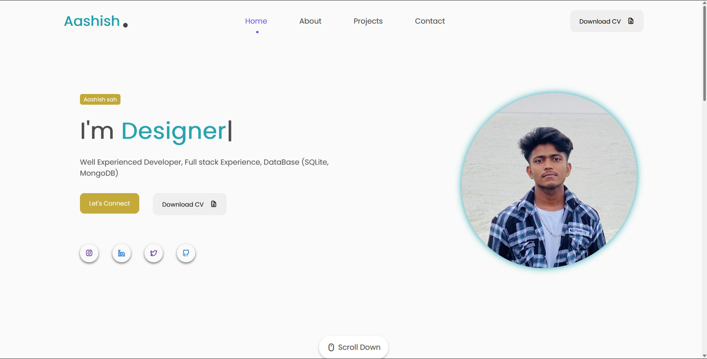**Result:**

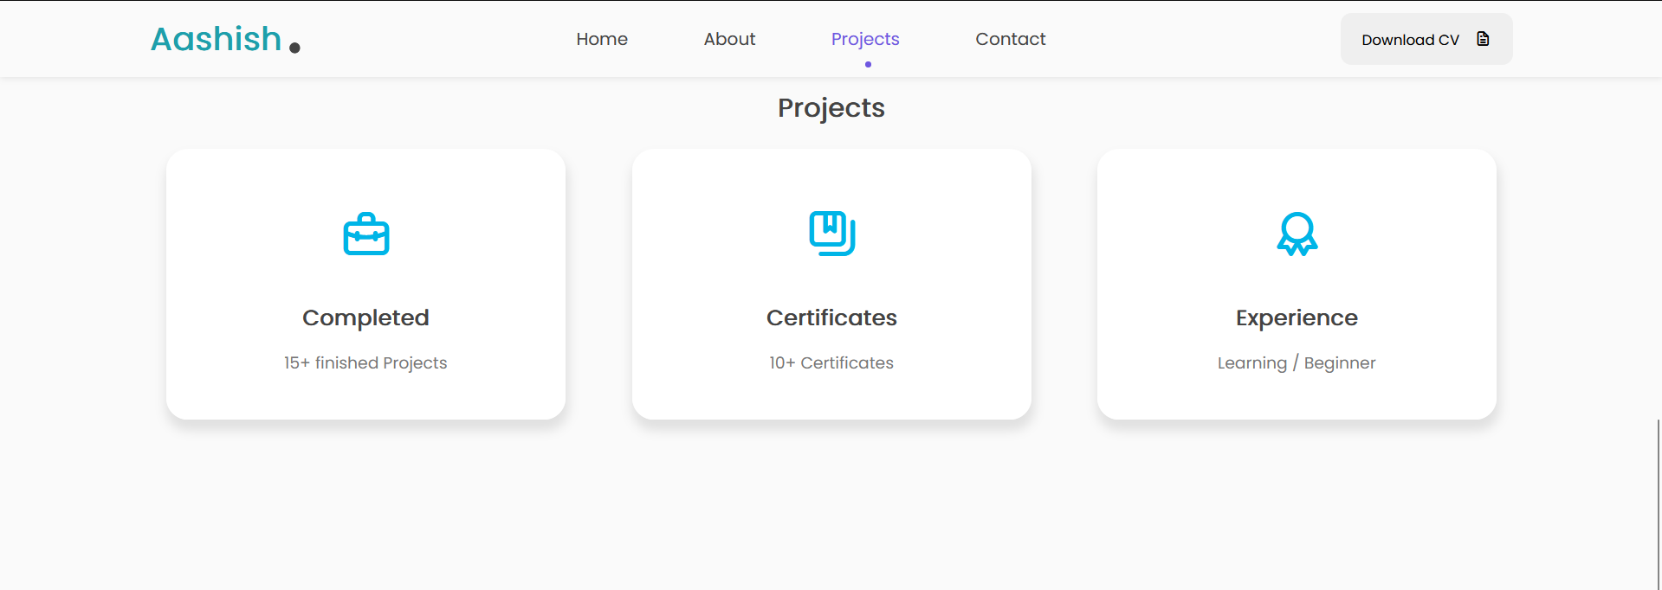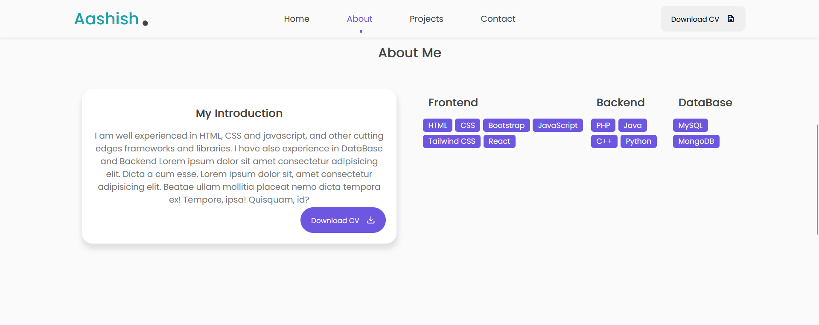

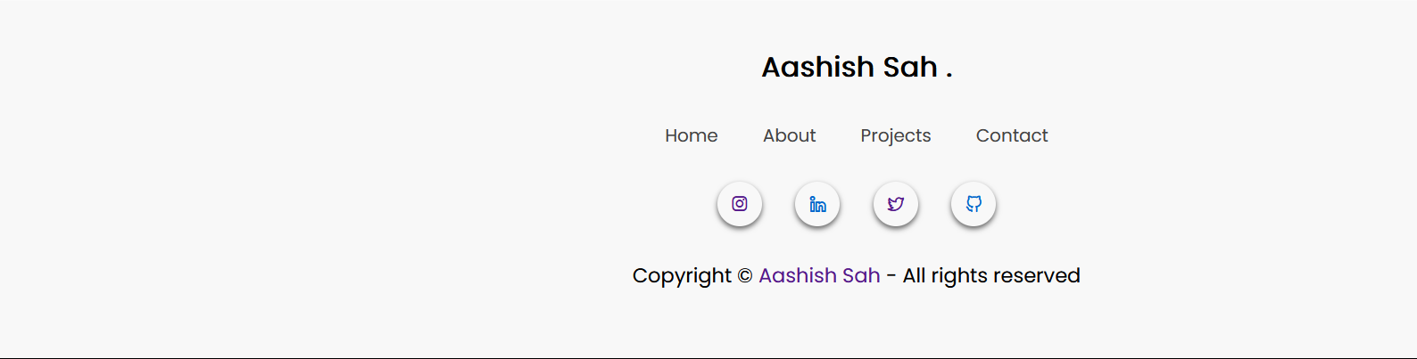  
  
  
  
  
  
  
  
  
  
  
  
  
  
  
  
  
  
  
  
  
  
  
  
  
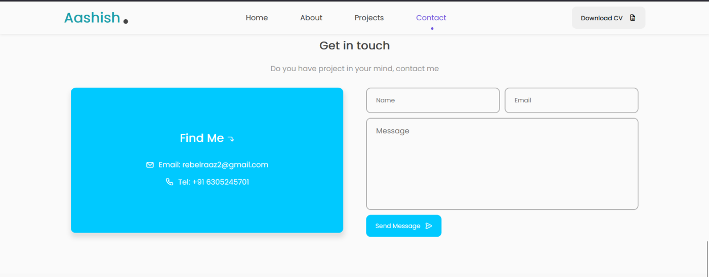Conclusion

This project effectively developed a personal portfolio website featuring a responsive design, interactive elements, and engaging animations. The final website showcases skills and projects dynamically, providing a compelling user experience. Despite challenges such as performance optimization and cross-browser compatibility, the project meets its goals and delivers a professional platform for personal branding. Future improvements may involve further optimization and additional features to enhance user engagement.

**Thank You**